**Attachments RenaultEW**

Contents

Bug ID : 01 1

Bug ID : 02 …………………………………………………………………………………………………………………………………………1

# Bug ID : 01

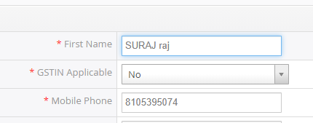

# Bug ID : 02

